Delivery of Sprint-3

SIMULATION CREATION

|  |  |
| --- | --- |
| Date | 05 Nov 2022 |
| Team ID | PNT2022TMID48082 |
| Project Name | Smart Waste Management System For Metropolitan Cities |

**TASK:**

***We can develop a Wowki simulation for detecting the bin level & publish data to IBM Cloud platform.***

# CODE FOR DETECTING BIN LEVEL AND DISPLAYING IT IN IBM CLOUD:

**esp32-dht22.ino:**

#include <WiFi.h>            // library for wifi

#include <PubSubClient.h>    // library for MQTT

#include <LiquidCrystal_I2C.h>

LiquidCrystal_I2C lcd(0x27, 20, 4);

//----------------------- credentials of IBM Accounts ------------------------------

#define ORG "4raljz"                // IBM organisation id

#define DEVICE_TYPE "pythoncode"    // Device type mentioned in ibm watson iot platform

#define DEVICE_ID "2811"            // Device ID mentioned in ibm watson iot platform

#define TOKEN "912419104024"        // Token

//----------------------- customise above values -----------------------------------------------------

char server[] = ORG ".messaging.internetofthings.ibmcloud.com";   // server name

char publishTopic[] = "iot-2/evt/data/fmt/json";                 // topic name and type of event perform and format in which data to be send

char topic[] = "iot-2/cmd/led/fmt/String";    // cmd Represent type and command is test format of strings

char authMethod[] = "use-token-auth";    // authentication method

char token[] = TOKEN;

char clientId[] = "d:" ORG ":" DEVICE_TYPE ":" DEVICE_ID;  //Client id

//---------------------------------------------------------------------------------------------------------------------

WiFiClient wifiClient;              // creating instance for wificlient

PubSubClient client(server, 1883, wifiClient);

#define ECHO_PIN 12

#define TRIG_PIN 13

float dist;

void setup()

{

**Serial**.begin(115200);

  pinMode(LED_BUILTIN, OUTPUT);

  pinMode(TRIG_PIN, OUTPUT);

  pinMode(ECHO_PIN, INPUT);

  //pir pin

  pinMode(34, INPUT);

  //ledpins

  pinMode(23, OUTPUT);

  pinMode(2, OUTPUT);

  pinMode(4, OUTPUT);

  pinMode(15, OUTPUT);

  lcd.init();

  lcd.backlight();

  lcd.setCursor(1, 0);

  lcd.print("");

  wifiConnect();

  mqttConnect();

}

float readcmCM()

{

  digitalWrite(TRIG_PIN, LOW);

  delayMicroseconds(2);

  digitalWrite(TRIG_PIN, HIGH);

  delayMicroseconds(10);

  digitalWrite(TRIG_PIN, LOW);

  int duration = pulseIn(ECHO_PIN, HIGH);

  return duration * 0.034 / 2;

}

void loop()

 {

  lcd.clear();

  publishData();

  delay(500);

  if (!client.loop())

    {

      mqttConnect();                                    // function call to connect to IBM

    }

}

/* --------------------------------retrieving to cloud-----------------------------------------------------*/

void wifiConnect()

{

**Serial**.print("Connecting to ");

**Serial**.print("Wifi");

  WiFi.begin("Wokwi-GUEST", "", 6);

  while (WiFi.status() != WL_CONNECTED)

    {

      delay(500);

**Serial**.print(".");

    }

**Serial**.print("WiFi connected, IP address: ");

**Serial**.println(WiFi.localIP());

}

void mqttConnect()

  {

    if (!client.connected())

      {

**Serial**.print("Reconnecting MQTT client to ");

**Serial**.println(server);

        while (!client.connect(clientId, authMethod, token))

          {

**Serial**.print(".");

            delay(500);

          }

        initManagedDevice();

**Serial**.println();

      }

  }

void initManagedDevice()

  {

    if (client.subscribe(topic))

      {

**Serial**.println("IBM subscribe to cmd OK");

      }

    else

      {

**Serial**.println("subscribe to cmd FAILED");

      }

  }

void publishData()

{

  float cm = readcmCM();

  if(digitalRead(34))                                 //pir motion detection

  {

**Serial**.println("Motion Detected");

**Serial**.println("Lid Opened");

    digitalWrite(15, HIGH);

 if(digitalRead(34)== true)

 {

  if(cm <= 60)                                                //Bin level detection

  {

    digitalWrite(2, HIGH);

**Serial**.println("High Alert!!!,Trash bin is about to be full");

**Serial**.println("Lid Closed");

    lcd.print("Full! Don't use");

    delay(2000);

    lcd.clear();

    digitalWrite(4, LOW);

    digitalWrite(23, LOW);

  }

  else if(cm > 60 && cm < 120)

  {

    digitalWrite(4, HIGH);

**Serial**.println("Warning!!,Trash is about to cross 50% of bin level");

    digitalWrite(2, LOW);

    digitalWrite(23, LOW);

  }

  else if(cm > 120)

  {

    digitalWrite(23, HIGH);

**Serial**.println("Bin is available");

    digitalWrite(2,LOW);

    digitalWrite(4, LOW);

  }

    delay(10000);

**Serial**.println("Lid Closed");

 }

 else

 {

**Serial**.println("No motion detected");

    digitalWrite(2, LOW);

    digitalWrite(15, LOW);

    digitalWrite(4, LOW);

    digitalWrite(23, LOW);

 }

}

  else

  {

    digitalWrite(15, LOW);

  }

  if(cm <= 60)

{

digitalWrite(21,HIGH);

String payload = "{\"High_Alert\":";

payload += cm;

payload += " }";

**Serial**.print("\n");

**Serial**.print("Sending payload: ");

**Serial**.println(payload);

if (client.publish(publishTopic, (char*) payload.c_str()))         // if data is uploaded to cloud successfully,prints publish ok else prints publish failed

{

**Serial**.println("Publish OK");

}

}

else if(cm <= 120)

{

digitalWrite(22,HIGH);

String payload = "{\"Warning\":";

payload += cm ;

payload += " }";

**Serial**.print("\n");

**Serial**.print("Sending payload: ");

**Serial**.println(payload);

if(client.publish(publishTopic, (char*) payload.c_str()))

{

**Serial**.println("Publish OK");

}

else

{

**Serial**.println("Publish FAILED");

}

}

else

{

**Serial**.println();

}

  float inches = (cm / 2.54);                                      //print on lcd

  lcd.setCursor(0,0);

  lcd.print("Inches");

  lcd.setCursor(4,0);

  lcd.setCursor(12,0);

  lcd.print("cm");

  lcd.setCursor(1,1);

  lcd.print(inches, 1);

  lcd.setCursor(11,1);

  lcd.print(cm, 1);

  lcd.setCursor(14,1);

  delay(1000);

  lcd.clear();

}

# diagram.json:

{

  "version": 1,

  "author": "Uri Shaked",

  "editor": "wokwi",

  "parts": [

    { "type": "wokwi-esp32-devkit-v1", "id": "esp", "top": 42.67, "left": 54.67, "attrs": {} },

    { "type": "wokwi-pir-motion-sensor", "id": "pir1", "top": -88.9, "left": -14.5, "attrs": {} },

    { "type": "wokwi-hc-sr04", "id": "ultrasonic1", "top": 95.1, "left": -140.5, "attrs": {} },

    {

      "type": "wokwi-lcd1602",

      "id": "lcd1",

      "top": 169.37,

      "left": 232.3,

      "attrs": { "pins": "i2c" }

    },

    {

      "type": "wokwi-led",

      "id": "led1",

      "top": -70.9,

      "left": 311.51,

      "attrs": { "color": "green" }

    },

    {

      "type": "wokwi-led",

      "id": "led2",

      "top": -23.57,

      "left": 316.84,

      "attrs": { "color": "yellow" }

    },

    {

      "type": "wokwi-led",

      "id": "led3",

      "top": 82.44,

      "left": 344.17,

      "attrs": { "color": "blue" }

    },

    { "type": "wokwi-led", "id": "led4", "top": 22.1, "left": 336.5, "attrs": { "color": "red" } },

    {

      "type": "wokwi-resistor",

      "id": "r1",

      "top": -30.23,

      "left": 250.17,

      "attrs": { "value": "1000" }

    },

    {

      "type": "wokwi-resistor",

      "id": "r5",

      "top": 11.77,

      "left": 246.83,

      "attrs": { "value": "1000" }

    },

    {

      "type": "wokwi-resistor",

      "id": "r6",

      "top": 67.1,

      "left": 254.16,

      "attrs": { "value": "1000" }

    },

    {

      "type": "wokwi-resistor",

      "id": "r7",

      "top": 124.44,

      "left": 273.5,

      "attrs": { "value": "1000" }

    }

  ],

  "connections": [

    [ "esp:TX0", "$serialMonitor:RX", "", [] ],

    [ "esp:RX0", "$serialMonitor:TX", "", [] ],

    [ "pir1:OUT", "esp:D34", "green", [ "v0" ] ],

    [ "esp:GND.2", "pir1:GND", "black", [ "h0" ] ],

    [ "esp:3V3", "pir1:VCC", "red", [ "v-1", "h22.2", "v54", "h-161.33", "v-10" ] ],

    [ "ultrasonic1:VCC", "esp:VIN", "red", [ "v0" ] ],

    [ "ultrasonic1:TRIG", "esp:D13", "green", [ "v0" ] ],

    [ "ultrasonic1:ECHO", "esp:D12", "yellow", [ "v0" ] ],

    [ "ultrasonic1:GND", "esp:GND.2", "black", [ "v0" ] ],

    [ "lcd1:VCC", "esp:VIN", "red", [ "h-36", "v60.89", "h-164.67", "v-3.33" ] ],

    [ "lcd1:SDA", "esp:D21", "cyan", [ "h-47.34", "v-111.94" ] ],

    [ "lcd1:SCL", "esp:D22", "white", [ "h-28", "v-150.11", "h-0.67" ] ],

    [ "lcd1:GND", "esp:GND.1", "black", [ "h0" ] ],

    [ "led1:A", "r1:2", "green", [ "v0" ] ],

    [ "r1:1", "esp:D23", "green", [ "v2.06", "h-70", "v86.67", "h-12.67" ] ],

    [ "led2:A", "r5:2", "gold", [ "v0" ] ],

    [ "r5:1", "esp:D4", "gold", [ "v2.73", "h-22.66", "v2.67" ] ],

    [ "led4:A", "r6:2", "red", [ "v14.07" ] ],

    [ "r6:1", "esp:D2", "red", [ "v50.73", "h-86.66", "v45.33" ] ],

    [ "led3:A", "r7:2", "blue", [ "v0" ] ],

    [ "r7:1", "esp:D15", "blue", [ "v0" ] ],

    [ "led1:C", "esp:GND.1", "black", [ "v37.07", "h-121.01", "v188" ] ],

    [ "led2:C", "esp:GND.1", "black", [ "v14.4", "h-116.34", "v160.67" ] ],

    [ "led4:C", "esp:GND.1", "black", [ "v0.07", "h-132.67", "v125.33" ] ],

    [ "led3:C", "esp:GND.1", "black", [ "v-8.27", "h-99.67", "v55.33", "h-32.67", "v17.33" ] ]

  ]

}

# CIRCUIT DIAGRAM:

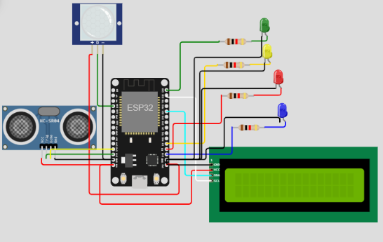

**SIMULATION IN WOKWI:**

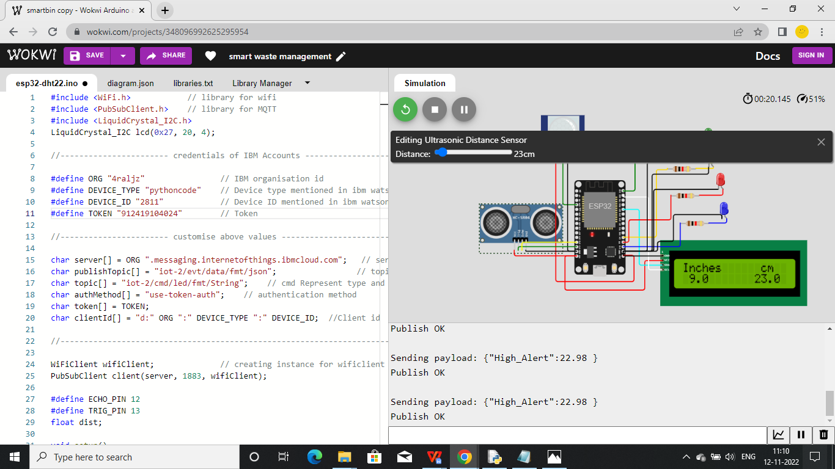

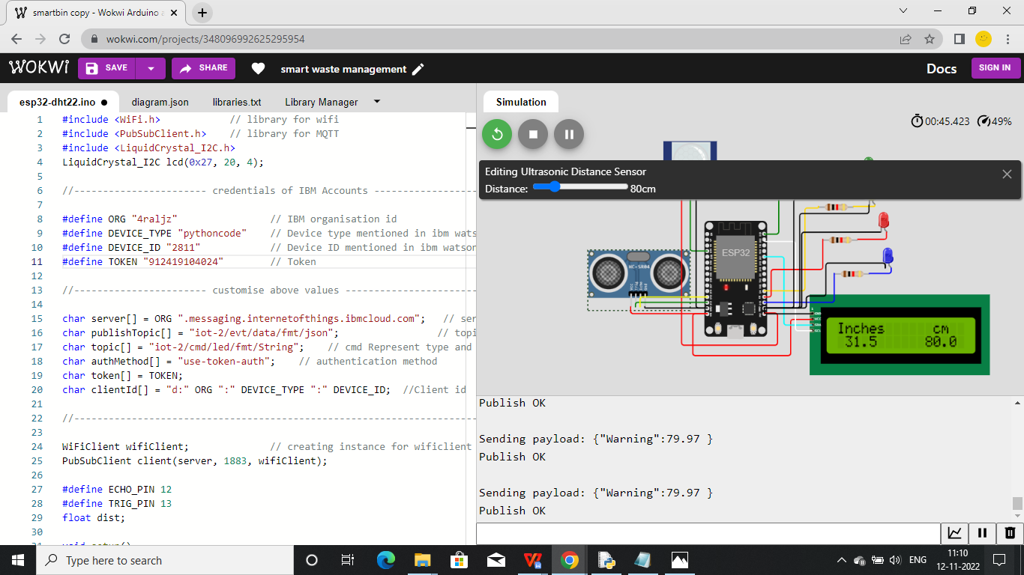

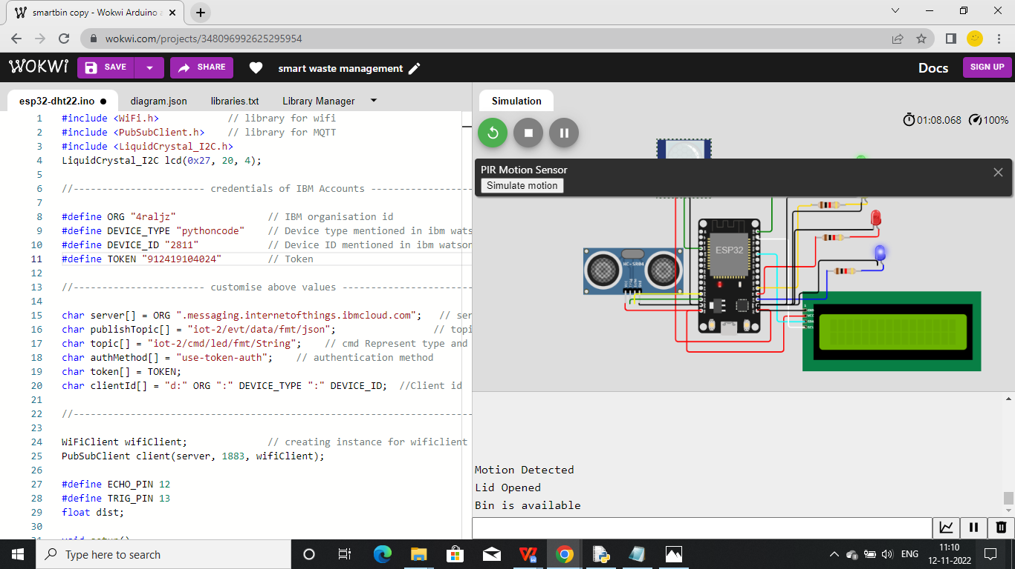

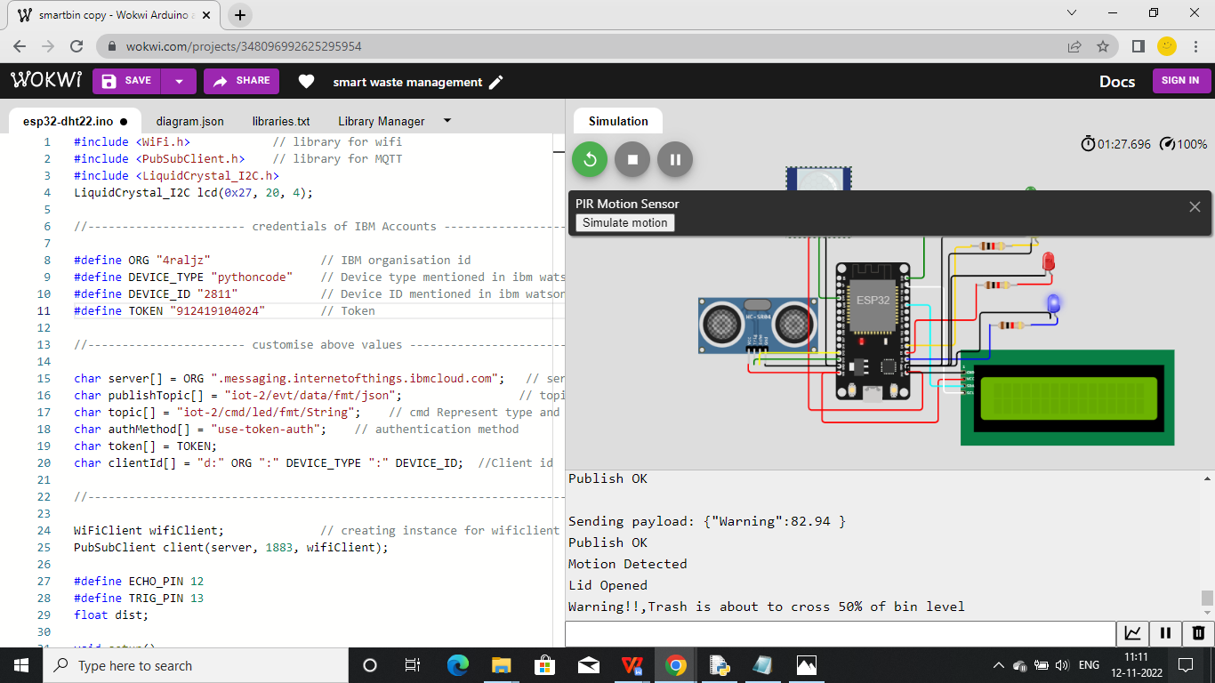

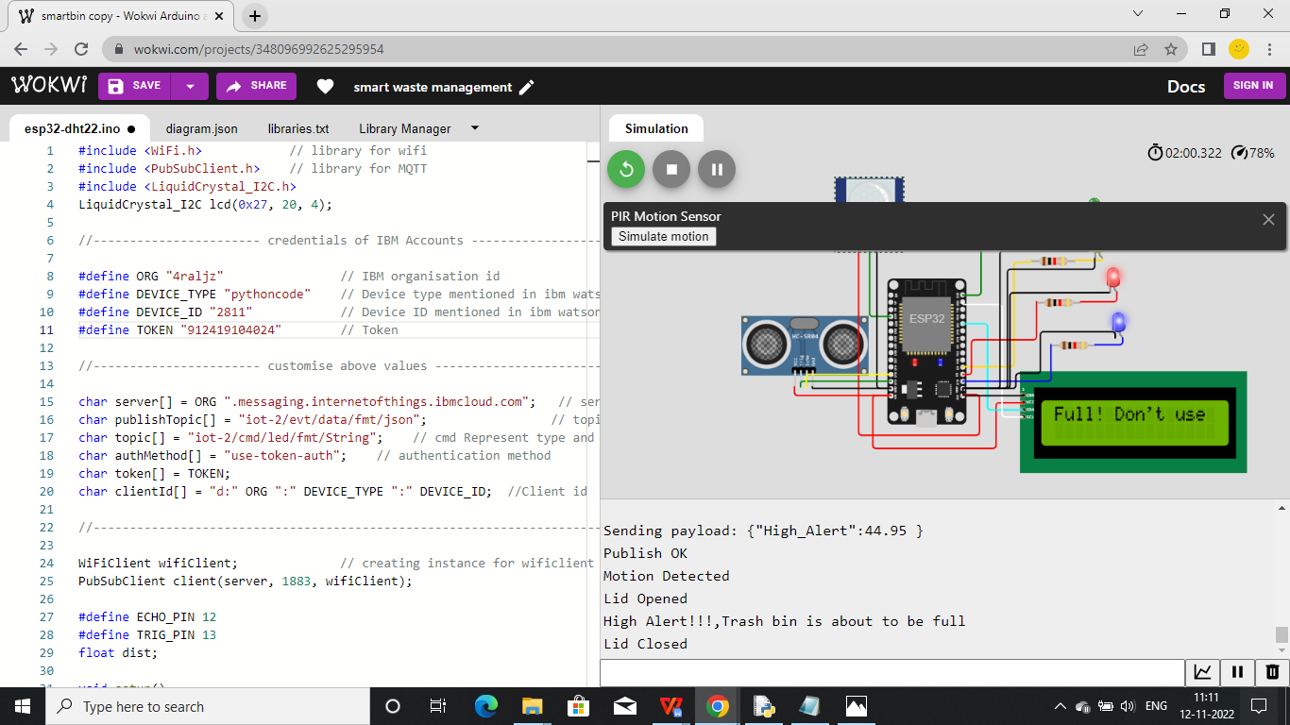

**WOKWI LINK: <https://wokwi.com/projects/348096992625295954>**

# IBM WATSON IOT PLATFORM OUTPUT:

